CST-361 Design Patterns in Java
Fredrick Onduso Ondieki
Activity 7A: Integration Layer Patterns
February 4, 2019

Assignment Write up:
CDI Overview
The most fundamental services provided by CDI are as follows:
Contexts: The ability to bind the lifecycle and interactions of stateful components to well-defined but extensible lifecycle contexts
Dependency injection: The ability to inject components into an application in a type safe way, including the ability to choose at deployment time which implementation of an interface to inject.
In other words, Contexts and Dependency Injection (CDI) for the Java EE platform is one of several Java EE 6 features that help to knit together the web tier and the transactional tier of the Java EE platform. CDI is a set of services that, used together, make it easy for developers to use enterprise beans along with JavaServer Faces technology in web applications. Designed for use with stateful objects, CDI also has many broader uses, allowing developers a great deal of flexibility to integrate various kinds of components in a loosely coupled but type safe way as we have seen above.
Singleton Design Pattern | Implementation
In a simple definition, the singleton pattern is a design pattern that restricts the instantiation of a class to one object. This design pattern is one of the simplest design patterns. Sometimes all a developer needs to have is only one instance of a class for example a single DB connection shared by multiple objects as compared to creating a separate DB connection for every object which may be costly. Similarly, there can be a single configuration manager or error manager in an application that handles all problems instead of creating multiple managers.
On this weeks project activity, I implemented the concept of the Singleton pattern by having a single database connection to the database (MusicDb) where all the music records will be stored compared to having multiple connections from the user input having DB connection instances every time a record is added, updated or removed. The SongsDbUtil file on this project handles all the database activities.
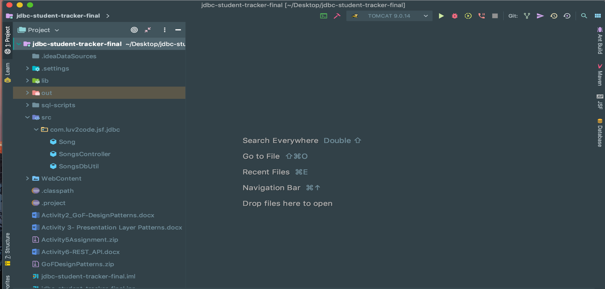
Deliverables:
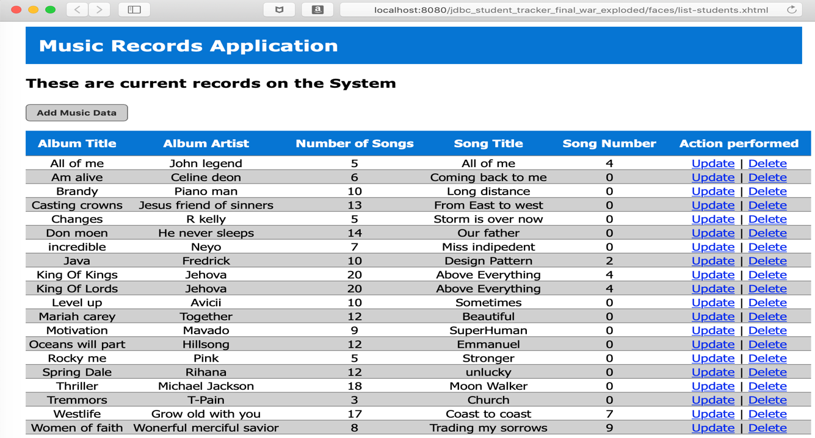
Project Structure from the IDE
Landing/Home page After program execution
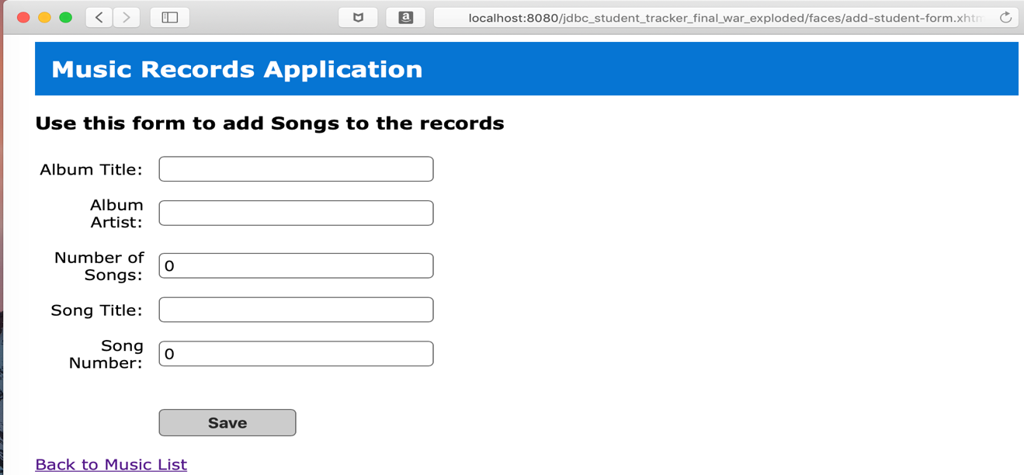
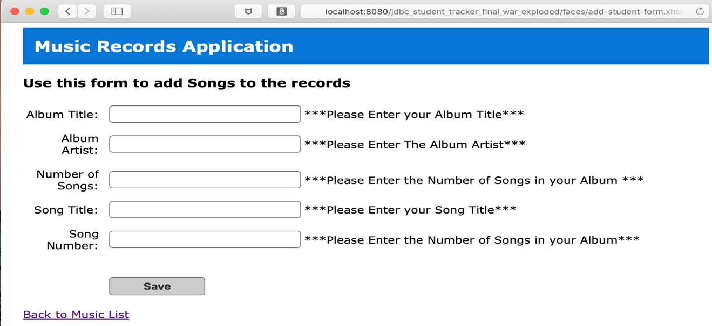
Songs Addition Entry Page
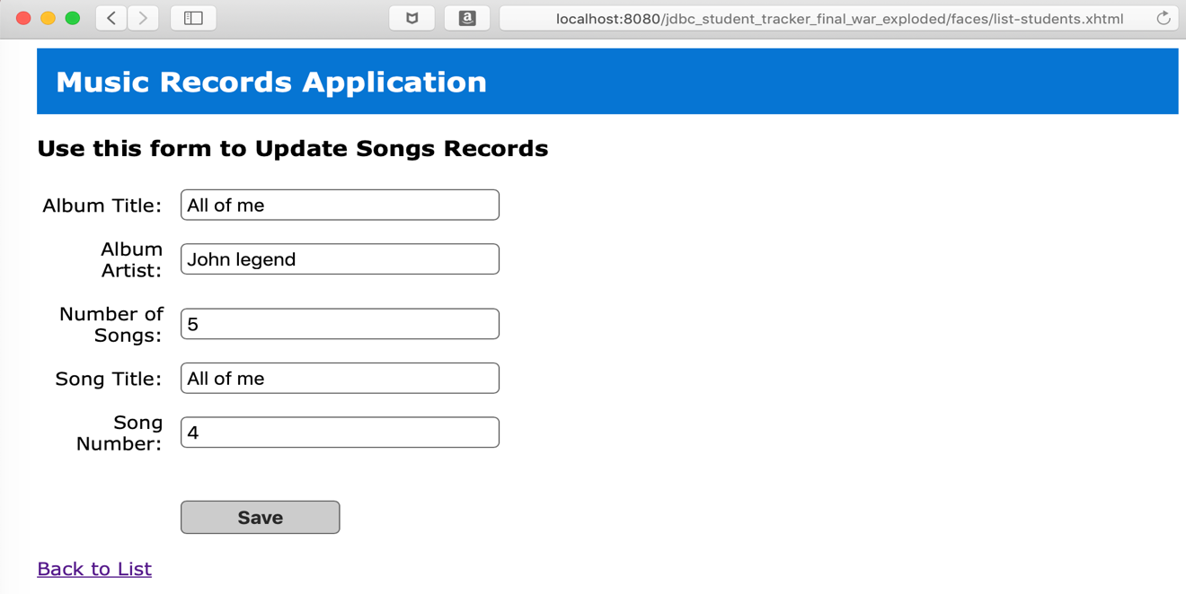
Security Validation not no enter null data to the Db
Update form to update song data
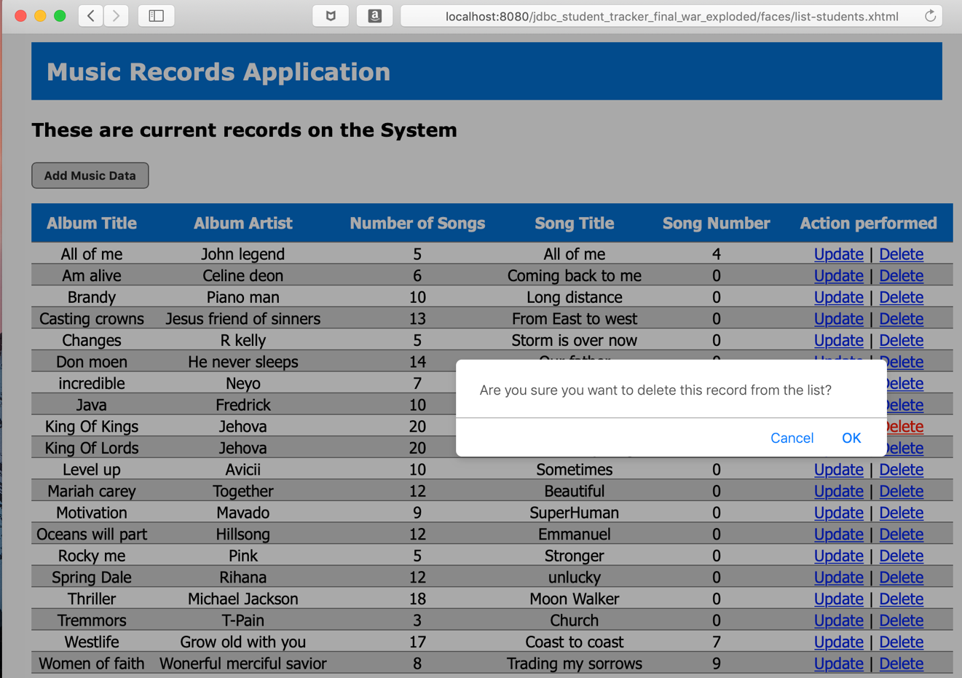
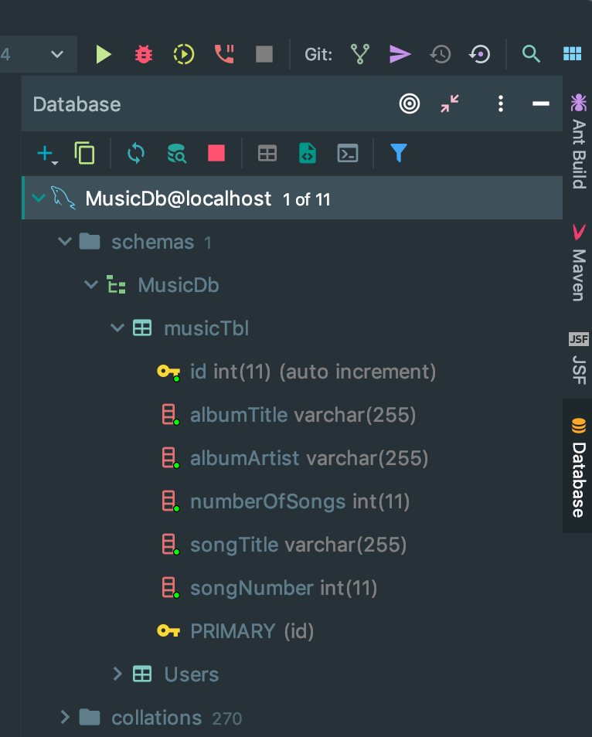
JavaScript security on the delete action
Database connection pool to MySQL relational Db

References
Design Pattern - Singleton Pattern. (n.d.). Retrieved February 4, 2019, from https://www.tutorialspoint.com/design_pattern/singleton_pattern.htm
Singleton Design Pattern | Implementation. (n.d.). Retrieved February 4, 2019, from https://www.geeksforgeeks.org/singleton-design-pattern/
The Java EE 6 Tutorial. Chapter 28 Introduction to Contexts and Dependency Injection for the Java EE Platform. (2013). Retrieved February 4, 2019, from https://docs.oracle.com/javaee/6/tutorial/doc/giwhb.html
The Java EE 6 Tutorial. (2013). Retrieved from https://docs.oracle.com/javaee/6/tutorial/doc/giwhl.html
Janssen, T. (2018, June 19). Design Patterns Explained – Dependency Injection with Code Examples. Retrieved February 4, 2019, from https://stackify.com/dependency-injection/

